SHD 861 test
1701 Unrepaired:
run all
progress variant=unrepaired completed=50/861 matched=50 mismatched=0
progress variant=unrepaired completed=100/861 matched=100 mismatched=0
progress variant=unrepaired completed=150/861 matched=150 mismatched=0
progress variant=unrepaired completed=200/861 matched=200 mismatched=0
progress variant=unrepaired completed=250/861 matched=250 mismatched=0
progress variant=unrepaired completed=300/861 matched=300 mismatched=0
progress variant=unrepaired completed=350/861 matched=350 mismatched=0
progress variant=unrepaired completed=400/861 matched=400 mismatched=0
progress variant=unrepaired completed=450/861 matched=450 mismatched=0
progress variant=unrepaired completed=500/861 matched=500 mismatched=0
progress variant=unrepaired completed=550/861 matched=550 mismatched=0
progress variant=unrepaired completed=600/861 matched=600 mismatched=0
progress variant=unrepaired completed=650/861 matched=650 mismatched=0
progress variant=unrepaired completed=700/861 matched=700 mismatched=0
progress variant=unrepaired completed=750/861 matched=750 mismatched=0
progress variant=unrepaired completed=800/861 matched=800 mismatched=0
progress variant=unrepaired completed=850/861 matched=850 mismatched=0
progress variant=unrepaired completed=861/861 matched=861 mismatched=0
============================================================
PINES SHD seed 1701 batch summary
variant = unrepaired
samples = 861
matched = 861
mismatched = 0
protocol_errors = 0
PASS: all requested RTL predictions match the frozen emulator.
results_csv = seed1701_unrepaired_batch_results.csv
============================================================
$finish called at time : 464941 ns
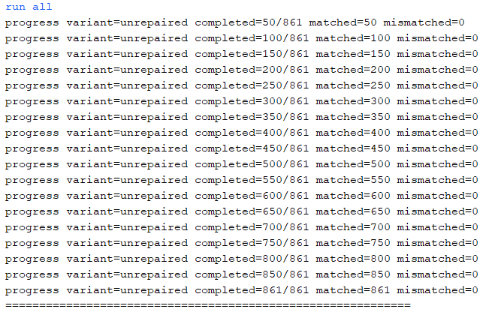
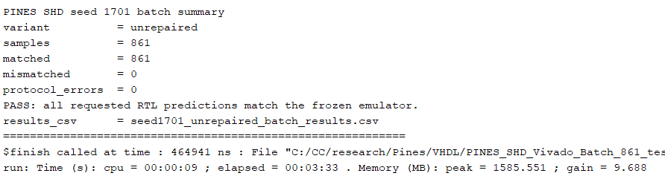

1701 Repaired:
run all
progress variant=repaired completed=50/861 matched=50 mismatched=0
progress variant=repaired completed=100/861 matched=100 mismatched=0
progress variant=repaired completed=150/861 matched=150 mismatched=0
progress variant=repaired completed=200/861 matched=200 mismatched=0
progress variant=repaired completed=250/861 matched=250 mismatched=0
progress variant=repaired completed=300/861 matched=300 mismatched=0
progress variant=repaired completed=350/861 matched=350 mismatched=0
progress variant=repaired completed=400/861 matched=400 mismatched=0
progress variant=repaired completed=450/861 matched=450 mismatched=0
progress variant=repaired completed=500/861 matched=500 mismatched=0
progress variant=repaired completed=550/861 matched=550 mismatched=0
progress variant=repaired completed=600/861 matched=600 mismatched=0
progress variant=repaired completed=650/861 matched=650 mismatched=0
progress variant=repaired completed=700/861 matched=700 mismatched=0
progress variant=repaired completed=750/861 matched=750 mismatched=0
progress variant=repaired completed=800/861 matched=800 mismatched=0
progress variant=repaired completed=850/861 matched=850 mismatched=0
progress variant=repaired completed=861/861 matched=861 mismatched=0
============================================================
PINES SHD seed 1701 batch summary
variant = repaired
samples = 861
matched = 861
mismatched = 0
protocol_errors = 0
PASS: all requested RTL predictions match the frozen emulator.
results_csv = seed1701_repaired_batch_results.csv
============================================================
$finish called at time : 464941 ns
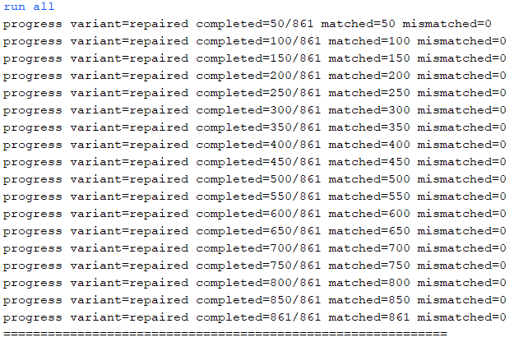
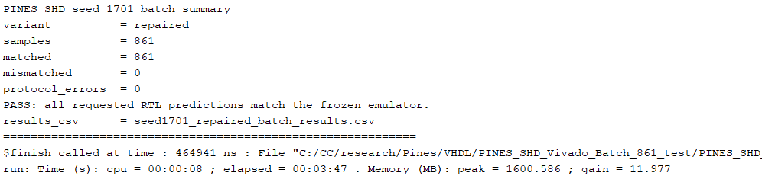

2718 unrepaired:
run all
progress variant=unrepaired completed=50/861 matched=50 mismatched=0
progress variant=unrepaired completed=100/861 matched=100 mismatched=0
progress variant=unrepaired completed=150/861 matched=150 mismatched=0
progress variant=unrepaired completed=200/861 matched=200 mismatched=0
progress variant=unrepaired completed=250/861 matched=250 mismatched=0
progress variant=unrepaired completed=300/861 matched=300 mismatched=0
progress variant=unrepaired completed=350/861 matched=350 mismatched=0
progress variant=unrepaired completed=400/861 matched=400 mismatched=0
progress variant=unrepaired completed=450/861 matched=450 mismatched=0
progress variant=unrepaired completed=500/861 matched=500 mismatched=0
progress variant=unrepaired completed=550/861 matched=550 mismatched=0
progress variant=unrepaired completed=600/861 matched=600 mismatched=0
progress variant=unrepaired completed=650/861 matched=650 mismatched=0
progress variant=unrepaired completed=700/861 matched=700 mismatched=0
progress variant=unrepaired completed=750/861 matched=750 mismatched=0
progress variant=unrepaired completed=800/861 matched=800 mismatched=0
progress variant=unrepaired completed=850/861 matched=850 mismatched=0
progress variant=unrepaired completed=861/861 matched=861 mismatched=0
============================================================
PINES SHD seed 2718 batch summary
variant = unrepaired
samples = 861
matched = 861
mismatched = 0
protocol_errors = 0
PASS: all requested RTL predictions match the frozen emulator.
results_csv = seed2718_unrepaired_batch_results.csv
============================================================
$finish called at time : 464941 ns : File "C:/CC/research/Pines/VHDL/PINES_SHD_Vivado_Batch_861_test/PINES_SHD_Vivado_Batch_861_test.srcs/sim_1/new/tb_shd_batch_base.sv" Line 204
run: Time (s): cpu = 00:00:10 ; elapsed = 00:03:36 . Memory (MB): peak = 1638.969 ; gain = 38.383
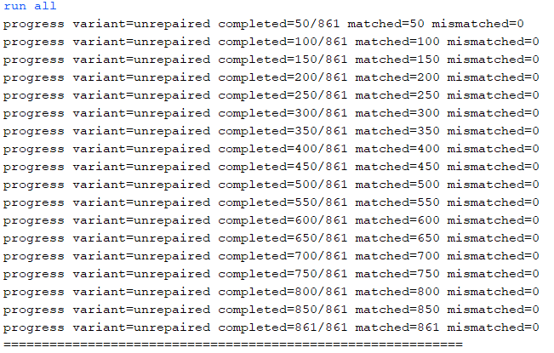
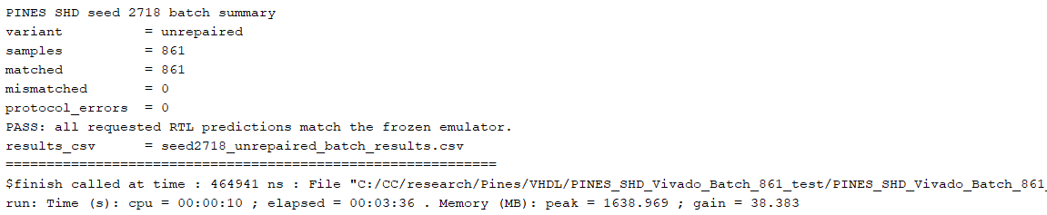

2718 repaired:
run all
progress variant=repaired completed=50/861 matched=50 mismatched=0
progress variant=repaired completed=100/861 matched=100 mismatched=0
progress variant=repaired completed=150/861 matched=150 mismatched=0
progress variant=repaired completed=200/861 matched=200 mismatched=0
progress variant=repaired completed=250/861 matched=250 mismatched=0
progress variant=repaired completed=300/861 matched=300 mismatched=0
progress variant=repaired completed=350/861 matched=350 mismatched=0
progress variant=repaired completed=400/861 matched=400 mismatched=0
progress variant=repaired completed=450/861 matched=450 mismatched=0
progress variant=repaired completed=500/861 matched=500 mismatched=0
progress variant=repaired completed=550/861 matched=550 mismatched=0
progress variant=repaired completed=600/861 matched=600 mismatched=0
progress variant=repaired completed=650/861 matched=650 mismatched=0
progress variant=repaired completed=700/861 matched=700 mismatched=0
progress variant=repaired completed=750/861 matched=750 mismatched=0
progress variant=repaired completed=800/861 matched=800 mismatched=0
progress variant=repaired completed=850/861 matched=850 mismatched=0
progress variant=repaired completed=861/861 matched=861 mismatched=0
============================================================
PINES SHD seed 2718 batch summary
variant = repaired
samples = 861
matched = 861
mismatched = 0
protocol_errors = 0
PASS: all requested RTL predictions match the frozen emulator.
results_csv = seed2718_repaired_batch_results.csv
============================================================
$finish called at time : 464941 ns : File "C:/CC/research/Pines/VHDL/PINES_SHD_Vivado_Batch_861_test/PINES_SHD_Vivado_Batch_861_test.srcs/sim_1/new/tb_shd_batch_base.sv" Line 204
run: Time (s): cpu = 00:00:14 ; elapsed = 00:04:03 . Memory (MB): peak = 1638.969 ; gain = 0.000
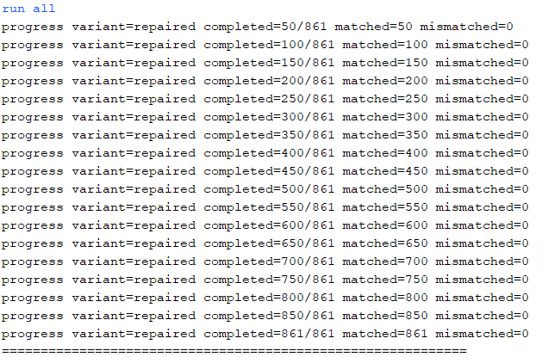
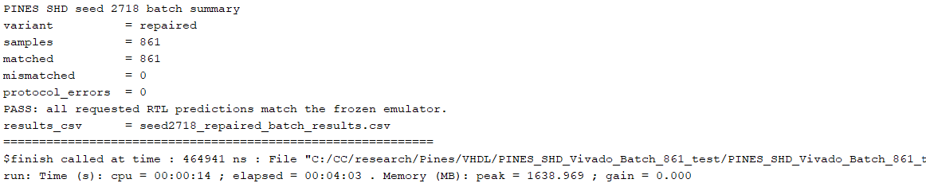

3141 unrepaired:
run all
progress variant=unrepaired completed=50/861 matched=50 mismatched=0
progress variant=unrepaired completed=100/861 matched=100 mismatched=0
progress variant=unrepaired completed=150/861 matched=150 mismatched=0
progress variant=unrepaired completed=200/861 matched=200 mismatched=0
progress variant=unrepaired completed=250/861 matched=250 mismatched=0
progress variant=unrepaired completed=300/861 matched=300 mismatched=0
progress variant=unrepaired completed=350/861 matched=350 mismatched=0
progress variant=unrepaired completed=400/861 matched=400 mismatched=0
progress variant=unrepaired completed=450/861 matched=450 mismatched=0
progress variant=unrepaired completed=500/861 matched=500 mismatched=0
progress variant=unrepaired completed=550/861 matched=550 mismatched=0
progress variant=unrepaired completed=600/861 matched=600 mismatched=0
progress variant=unrepaired completed=650/861 matched=650 mismatched=0
progress variant=unrepaired completed=700/861 matched=700 mismatched=0
progress variant=unrepaired completed=750/861 matched=750 mismatched=0
progress variant=unrepaired completed=800/861 matched=800 mismatched=0
progress variant=unrepaired completed=850/861 matched=850 mismatched=0
progress variant=unrepaired completed=861/861 matched=861 mismatched=0
============================================================
PINES SHD seed 3141 batch summary
variant = unrepaired
samples = 861
matched = 861
mismatched = 0
protocol_errors = 0
PASS: all requested RTL predictions match the frozen emulator.
results_csv = seed3141_unrepaired_batch_results.csv
============================================================
$finish called at time : 464941 ns
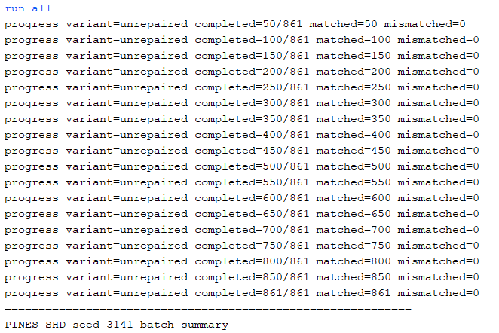
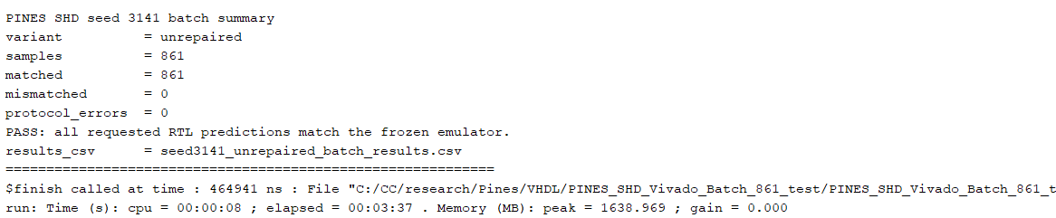

3141 repaired:
run all
progress variant=repaired completed=50/861 matched=50 mismatched=0
progress variant=repaired completed=100/861 matched=100 mismatched=0
progress variant=repaired completed=150/861 matched=150 mismatched=0
progress variant=repaired completed=200/861 matched=200 mismatched=0
progress variant=repaired completed=250/861 matched=250 mismatched=0
progress variant=repaired completed=300/861 matched=300 mismatched=0
progress variant=repaired completed=350/861 matched=350 mismatched=0
progress variant=repaired completed=400/861 matched=400 mismatched=0
progress variant=repaired completed=450/861 matched=450 mismatched=0
progress variant=repaired completed=500/861 matched=500 mismatched=0
progress variant=repaired completed=550/861 matched=550 mismatched=0
progress variant=repaired completed=600/861 matched=600 mismatched=0
progress variant=repaired completed=650/861 matched=650 mismatched=0
progress variant=repaired completed=700/861 matched=700 mismatched=0
progress variant=repaired completed=750/861 matched=750 mismatched=0
progress variant=repaired completed=800/861 matched=800 mismatched=0
progress variant=repaired completed=850/861 matched=850 mismatched=0
progress variant=repaired completed=861/861 matched=861 mismatched=0
============================================================
PINES SHD seed 3141 batch summary
variant = repaired
samples = 861
matched = 861
mismatched = 0
protocol_errors = 0
PASS: all requested RTL predictions match the frozen emulator.
results_csv = seed3141_repaired_batch_results.csv
============================================================
$finish called at time : 464941 ns
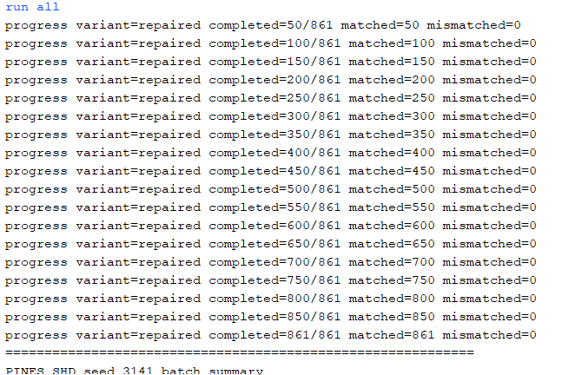
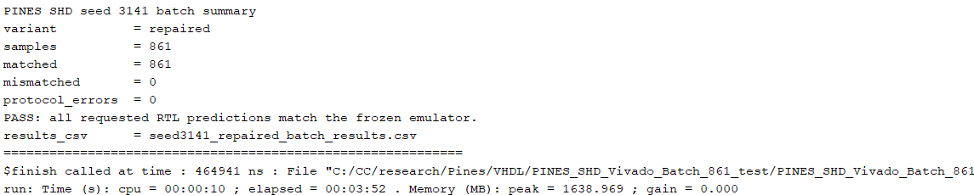

5772 unrepaired:
run all
progress variant=unrepaired completed=50/861 matched=50 mismatched=0
progress variant=unrepaired completed=100/861 matched=100 mismatched=0
progress variant=unrepaired completed=150/861 matched=150 mismatched=0
progress variant=unrepaired completed=200/861 matched=200 mismatched=0
progress variant=unrepaired completed=250/861 matched=250 mismatched=0
progress variant=unrepaired completed=300/861 matched=300 mismatched=0
progress variant=unrepaired completed=350/861 matched=350 mismatched=0
progress variant=unrepaired completed=400/861 matched=400 mismatched=0
progress variant=unrepaired completed=450/861 matched=450 mismatched=0
progress variant=unrepaired completed=500/861 matched=500 mismatched=0
progress variant=unrepaired completed=550/861 matched=550 mismatched=0
progress variant=unrepaired completed=600/861 matched=600 mismatched=0
progress variant=unrepaired completed=650/861 matched=650 mismatched=0
progress variant=unrepaired completed=700/861 matched=700 mismatched=0
progress variant=unrepaired completed=750/861 matched=750 mismatched=0
progress variant=unrepaired completed=800/861 matched=800 mismatched=0
progress variant=unrepaired completed=850/861 matched=850 mismatched=0
progress variant=unrepaired completed=861/861 matched=861 mismatched=0
============================================================
PINES SHD seed 5772 batch summary
variant = unrepaired
samples = 861
matched = 861
mismatched = 0
protocol_errors = 0
PASS: all requested RTL predictions match the frozen emulator.
results_csv = seed5772_unrepaired_batch_results.csv
============================================================
$finish called at time : 464941 ns
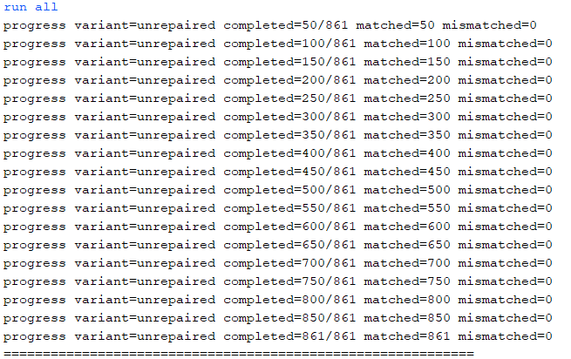
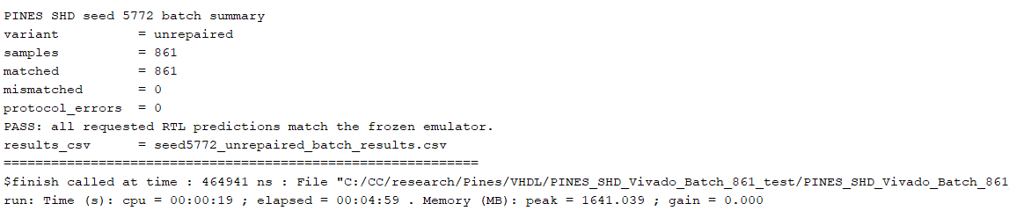

5772 repaired:
run all
progress variant=repaired completed=50/861 matched=50 mismatched=0
progress variant=repaired completed=100/861 matched=100 mismatched=0
progress variant=repaired completed=150/861 matched=150 mismatched=0
progress variant=repaired completed=200/861 matched=200 mismatched=0
progress variant=repaired completed=250/861 matched=250 mismatched=0
progress variant=repaired completed=300/861 matched=300 mismatched=0
progress variant=repaired completed=350/861 matched=350 mismatched=0
progress variant=repaired completed=400/861 matched=400 mismatched=0
progress variant=repaired completed=450/861 matched=450 mismatched=0
progress variant=repaired completed=500/861 matched=500 mismatched=0
progress variant=repaired completed=550/861 matched=550 mismatched=0
progress variant=repaired completed=600/861 matched=600 mismatched=0
progress variant=repaired completed=650/861 matched=650 mismatched=0
progress variant=repaired completed=700/861 matched=700 mismatched=0
progress variant=repaired completed=750/861 matched=750 mismatched=0
progress variant=repaired completed=800/861 matched=800 mismatched=0
progress variant=repaired completed=850/861 matched=850 mismatched=0
progress variant=repaired completed=861/861 matched=861 mismatched=0
============================================================
PINES SHD seed 5772 batch summary
variant = repaired
samples = 861
matched = 861
mismatched = 0
protocol_errors = 0
PASS: all requested RTL predictions match the frozen emulator.
results_csv = seed5772_repaired_batch_results.csv
============================================================
$finish called at time : 464941 ns
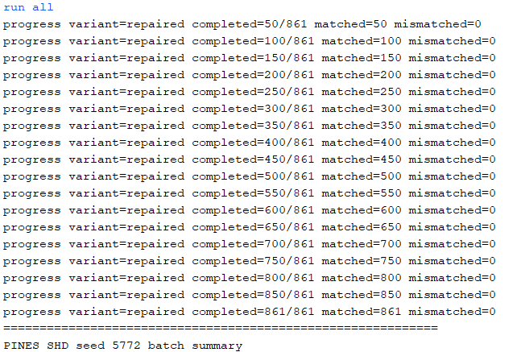
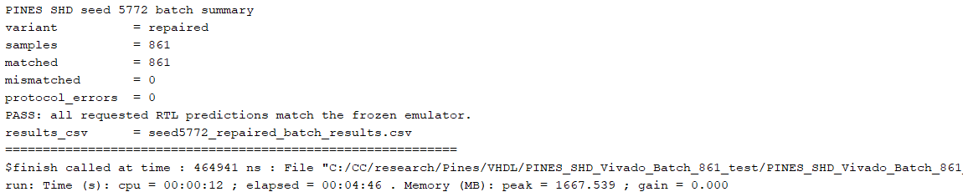

8119 unrepaired:
run all
progress variant=unrepaired completed=50/861 matched=50 mismatched=0
progress variant=unrepaired completed=100/861 matched=100 mismatched=0
progress variant=unrepaired completed=150/861 matched=150 mismatched=0
progress variant=unrepaired completed=200/861 matched=200 mismatched=0
progress variant=unrepaired completed=250/861 matched=250 mismatched=0
progress variant=unrepaired completed=300/861 matched=300 mismatched=0
progress variant=unrepaired completed=350/861 matched=350 mismatched=0
progress variant=unrepaired completed=400/861 matched=400 mismatched=0
progress variant=unrepaired completed=450/861 matched=450 mismatched=0
progress variant=unrepaired completed=500/861 matched=500 mismatched=0
progress variant=unrepaired completed=550/861 matched=550 mismatched=0
progress variant=unrepaired completed=600/861 matched=600 mismatched=0
progress variant=unrepaired completed=650/861 matched=650 mismatched=0
progress variant=unrepaired completed=700/861 matched=700 mismatched=0
progress variant=unrepaired completed=750/861 matched=750 mismatched=0
progress variant=unrepaired completed=800/861 matched=800 mismatched=0
progress variant=unrepaired completed=850/861 matched=850 mismatched=0
progress variant=unrepaired completed=861/861 matched=861 mismatched=0
============================================================
PINES SHD seed 8119 batch summary
variant = unrepaired
samples = 861
matched = 861
mismatched = 0
protocol_errors = 0
PASS: all requested RTL predictions match the frozen emulator.
results_csv = seed8119_unrepaired_batch_results.csv
============================================================
$finish called at time : 464941 ns
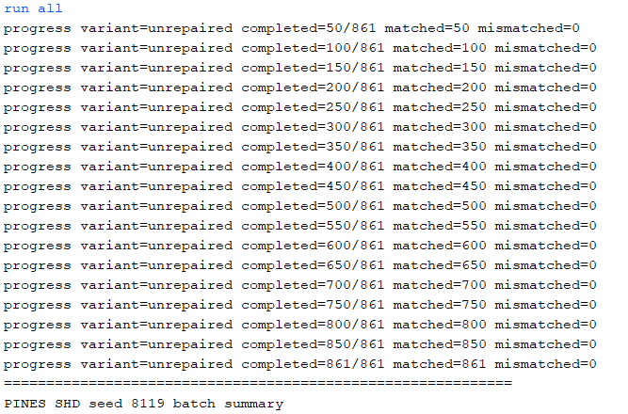
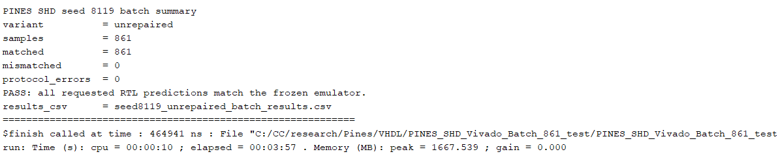

8119 repaired:
run all
progress variant=repaired completed=50/861 matched=50 mismatched=0
progress variant=repaired completed=100/861 matched=100 mismatched=0
progress variant=repaired completed=150/861 matched=150 mismatched=0
progress variant=repaired completed=200/861 matched=200 mismatched=0
progress variant=repaired completed=250/861 matched=250 mismatched=0
progress variant=repaired completed=300/861 matched=300 mismatched=0
progress variant=repaired completed=350/861 matched=350 mismatched=0
progress variant=repaired completed=400/861 matched=400 mismatched=0
progress variant=repaired completed=450/861 matched=450 mismatched=0
progress variant=repaired completed=500/861 matched=500 mismatched=0
progress variant=repaired completed=550/861 matched=550 mismatched=0
progress variant=repaired completed=600/861 matched=600 mismatched=0
progress variant=repaired completed=650/861 matched=650 mismatched=0
progress variant=repaired completed=700/861 matched=700 mismatched=0
progress variant=repaired completed=750/861 matched=750 mismatched=0
progress variant=repaired completed=800/861 matched=800 mismatched=0
progress variant=repaired completed=850/861 matched=850 mismatched=0
progress variant=repaired completed=861/861 matched=861 mismatched=0
============================================================
PINES SHD seed 8119 batch summary
variant = repaired
samples = 861
matched = 861
mismatched = 0
protocol_errors = 0
PASS: all requested RTL predictions match the frozen emulator.
results_csv = seed8119_repaired_batch_results.csv
============================================================
$finish called at time : 464941 ns
